
Optimize 25 Testing Automation: Setup Guide

Prepared by
Hari Yarapotina
Solution Architect

Contributors
List of Contributors

Revision and Signoff Sheet
Change Record
Date | Author | Version | Change Reference
 | Hyarapotina | 1.0 | Initial draft for review/discussion

Reviewers
Name | Version Approved | Position | Date

Table of Contents
Table of Contents
1 Introduction 5
1.1 Pre-requisites 5
1.2 Installation 5
1.3 Dynamics 365 – Trail Environment Setup 7
1.4 Setting up Automation Test Project 8
1.5 Running Tests 10
1.6 Resources 10

- Introduction
Automated end-to-end testing is an important process during Dynamics 365 implementations. Automation helps to test the code quickly by replicating the business process flows and deploying the code faster with high confidence. Historically, setting the automation testing in Dynamics 365 projects is hard and various frameworks were available like EasyRepo based on Open-Source Selenium web drivers.
In this guide, we are introducing Playwright for end-to-end automation testing with Dynamics 365. Playwright Library provides unified APIs for launching and interacting with browsers, while Playwright Test provides all this plus a fully managed end-to-end Test Runner and experience.
  - Pre-requisites
Playwright: An open-source library from Microsoft that is built for developers and testers to write end-to-end tests that run on all modern web browsers. Supports JavaScript, TypeScript, C# and Python.
- Native Installation:
  - https://playwright.dev
- Playwright Test for VSCode - Visual Studio Marketplace
  - Version – v1.19+ or newer
  - Playwright NPM Package
Playwright supports testing on Windows, Linux, and macOS, locally or on CI, headless or headed with native mobile emulation of Google Chrome for Android and Mobile Safari.
Azure Subscription (optional): TBR. An active Microsoft Azure subscription is recommended. This is a requirement if you plan to execute automated tests in Microsoft Azure or integrate load testing into your CI/CD pipelines.
  - Installation
Playwright can be installed in two ways i.e., natively using npm or yarn. Alternatively, you can also get started and run your tests using the VS Code Extension.
For Automation testing here, we will choose the second option i.e., Playwright VS Code extension.
- Install the VS Code extension from the marketplace or from the extensions tab in VS Code.
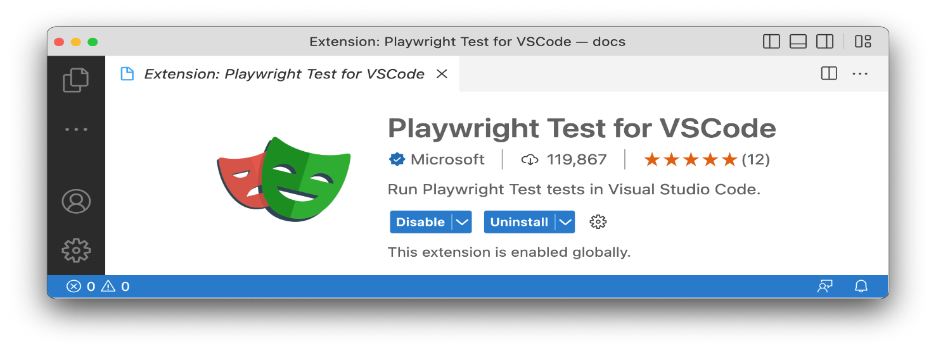
- After installation, open the command panel and type:
Install Playwright
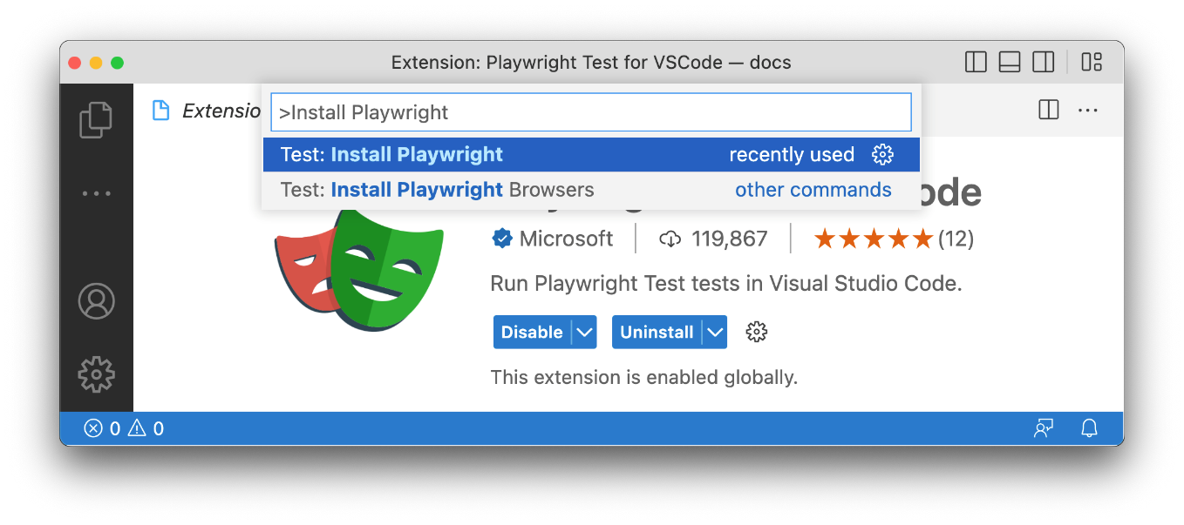
- Select Test: Install Playwright and choose the browsers you would like to run your tests on. These can be later configured in the playwright.config file.
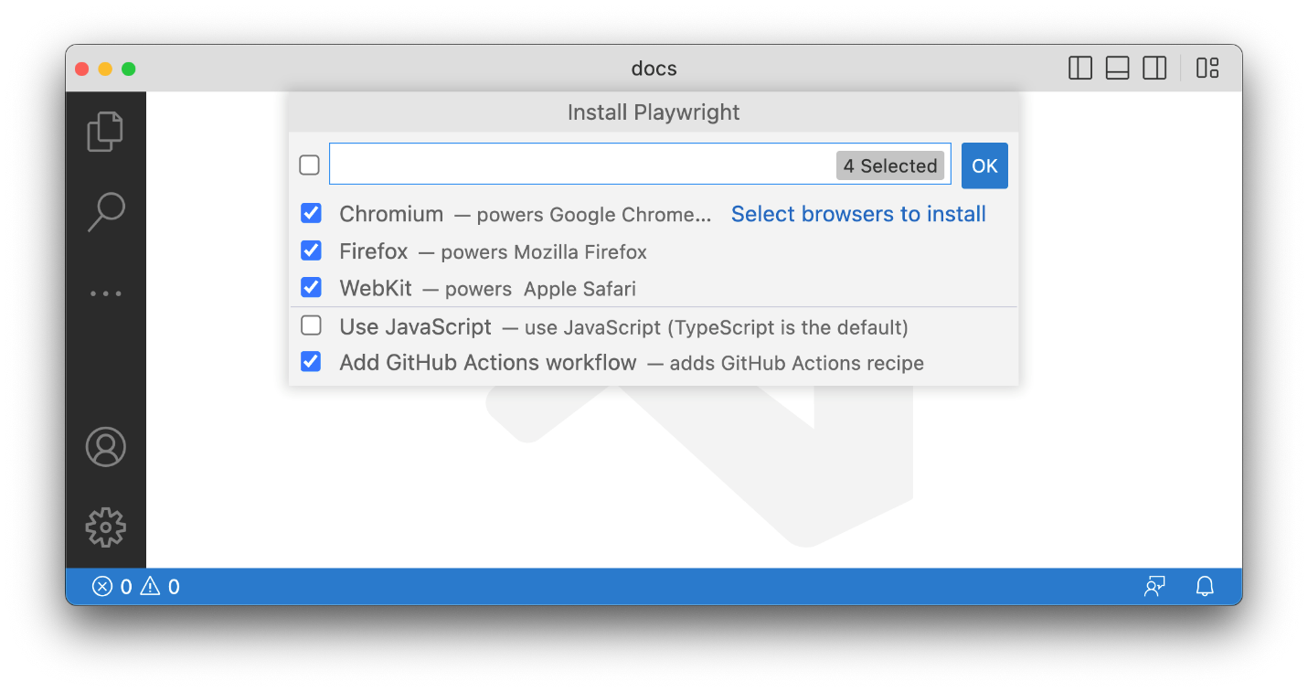
This will complete the installation needed for setting up the Automation Test project.
  - Dynamics 365 – Trail Environment Setup
- Create a Trial environment by navigating to
  - Start a Free Trial for Microsoft Dynamics 365| Microsoft Dynamics 365
- Select Dynamics 365 Customer Service under Service

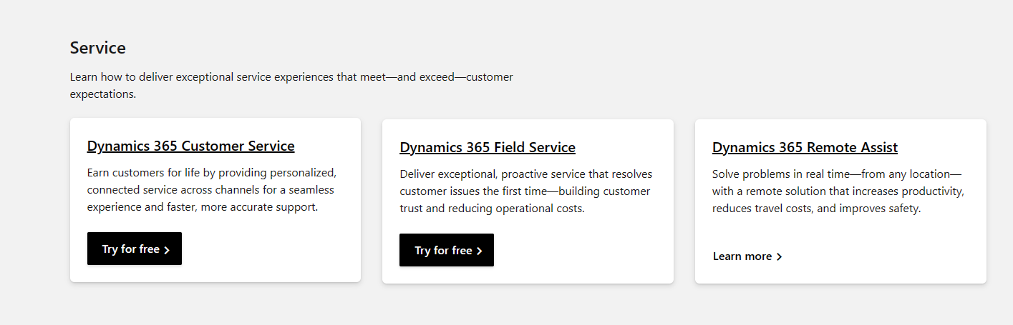

This prompts to enter the “Email Address” to continue.
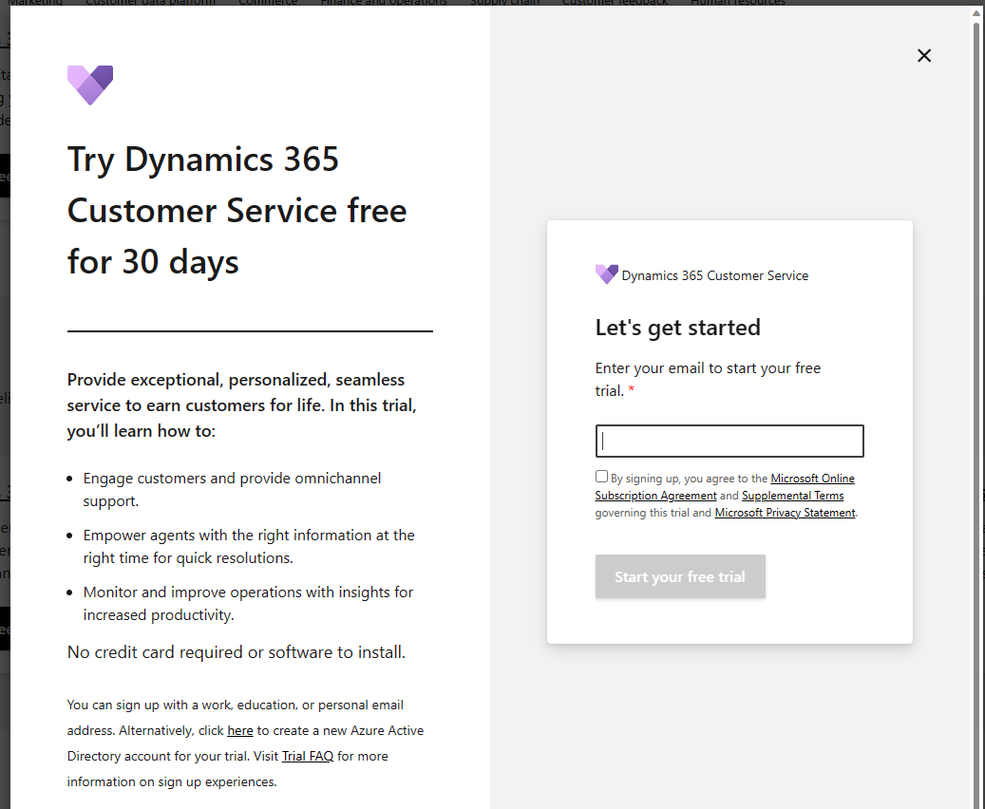
- Enter your email address and start your feel trail. (Trial is valid for 30 days)
- Customer Service environment will be created.
- Turn off security defaults. For automation testing, it is
  - Security defaults and Conditional Access - Microsoft 365 Business Premium | Microsoft Learn
  - Introducing security defaults - Microsoft Community Hub

- Go to the Azure Active directory and add additional users as needed then assign security roles.
  - At minimum, create a test automation account to use it with testing.
    - test.automation@domain.com
  - Setting up Automation Test Project
To facilitate the test automation in Dynamics 365 Implementations, FastTrack team has provided a sample automation project and below are the instructions to set it up. This project is based on Playwright test library.
Follow the steps below to set up a Test Automation:
- Download/Clone the sample Automation project from the github repository link below.
  - https://microsoft-my.sharepoint.com/:u:/p/hyarapotina/EfVv6YdR3epJl0vrqZOOKC4B01h57SeMub0jgFa1waVeSw?e=L8wRJe
- Extract the project folder and open this in Visual Studio Code.
- Here is the folder structure:
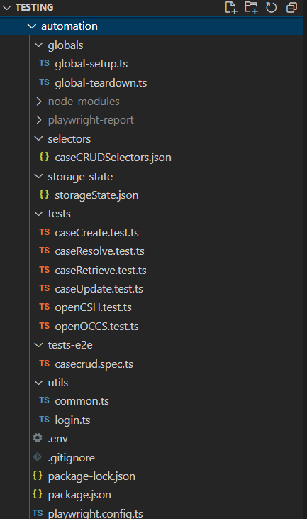

- Open the .env File and edit the file to include your environment details.
  - DYN365_ORGURL='https://org212fbf02.crm.dynamics.com/'
  - DYN365_USERNAME=’<<<Replace with the Username>>>’
  - DYN365_PASSWORD='<<<Replace with the password'>>>’
  - CSH_APPID=’<<<Replace with the Customer Service Hub App Id>>>’
  - CASE_NUMBER=’<<<Replace with a Case Number that you already have>>>’ This is only used if you are to run the unit tests. By default, the project setup to run the end-to-end tests in the tests-e2e folder.
- Please note that, this sample test project has end to end tests for the Case/Incident covering Case Create, Retrieve, Update and Resolve. These cases are based on the out of the box forms. Recommended to run this on a trial environment to test. Once you were able to configure and test this, you can switch the configuration for your org.

  - Running Tests
By default, the sample project has a configuration setting pointing to end-to-end tests folder. The instructions below are to execute the end-to-end tests from the UI using VS Code. To execute the unit tests, you can change the setting “testDir” within playwright.config.ts file as needed.
For end-to-end tests the testDir must be ‘./tests-e2e’
For unit tests the testDir value must be ‘./tests’
End-To-End test executions (from VS Code UI):
- From the Visual Studio, navigate to the Testing area on the left menu. Click to open “Test Explorer”
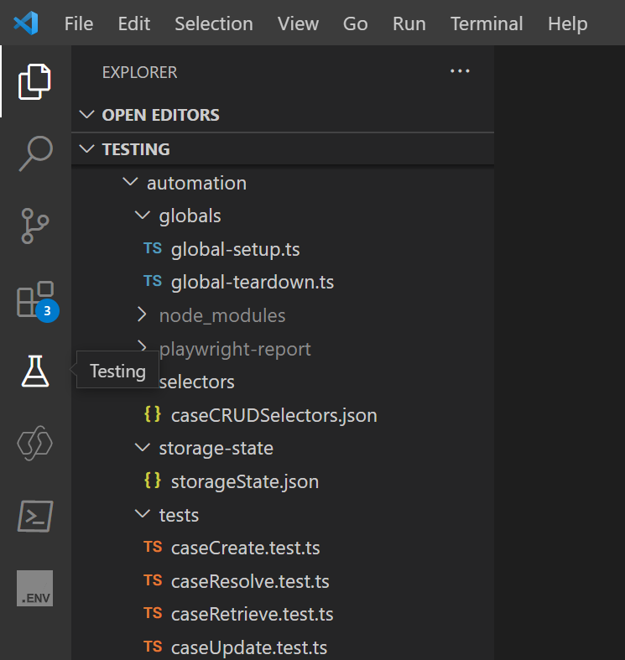
- Test Explorer would display the folder structure and the end-to-end test cases as shown below.
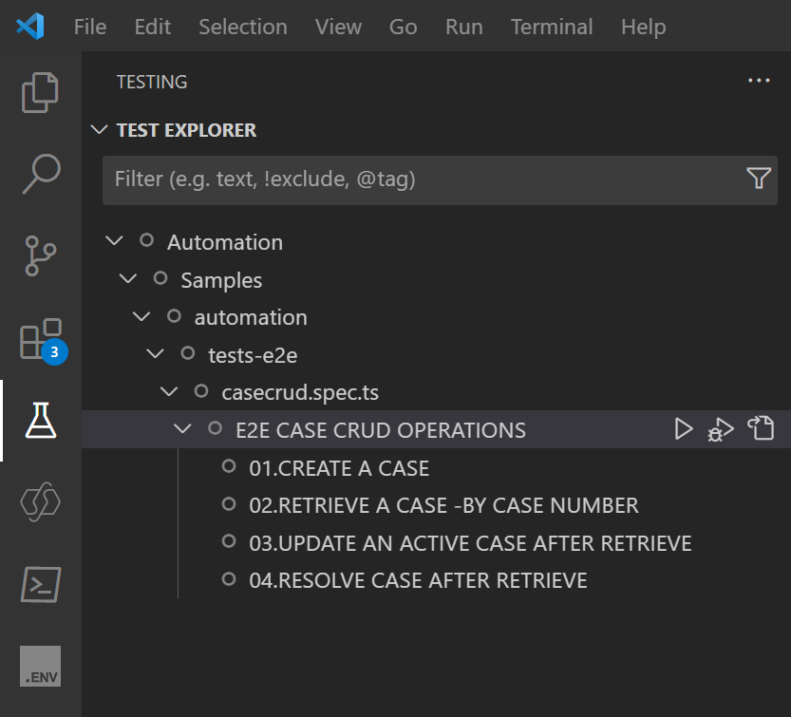
- To run the test cases you can click on the play button next to the casecrud.spec.ts file as shown below. By default, VS Code test runner runs your tests on the default browser of chrome.
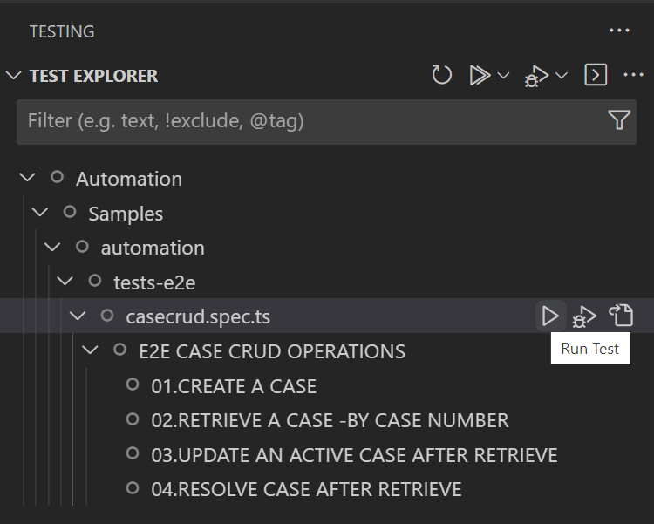

- To run on different browsers, click the play button on the top of the test explorer and choose another browser you wish to run the tests on.
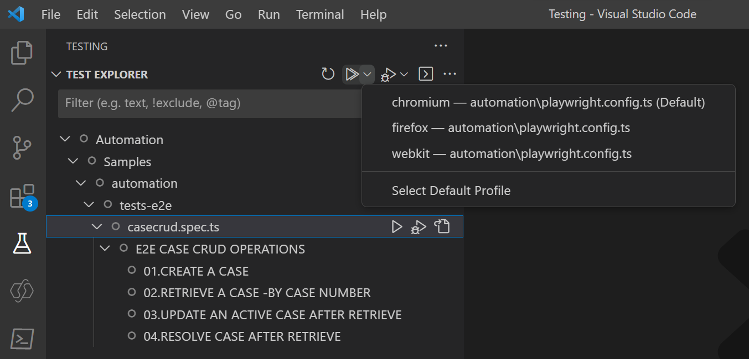

- After successful test executions, there will be a check mark next to each test. 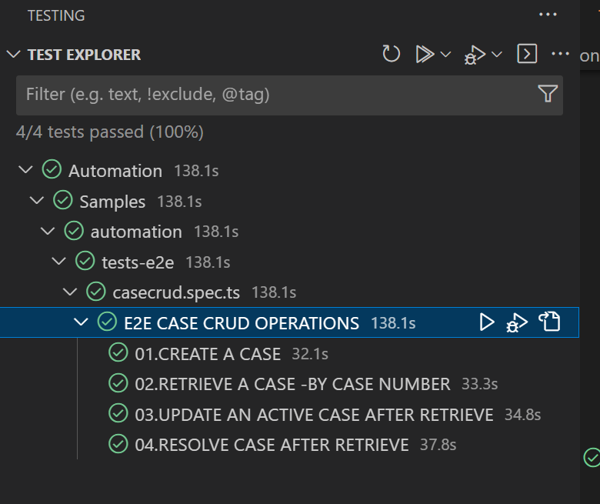
  - Resources
Playwright Overview - https://playwright.dev/docs/intro
Playwright with Visual Studio Code - https://playwright.dev/docs/getting-started-vscode

